The wargames club  « Les Nerviens » | The Domaine Napoléon | The French Wargames Federation | The town of Seclin
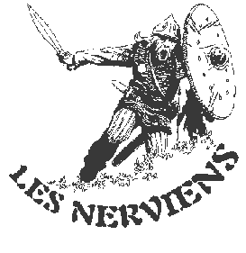 |  |  | 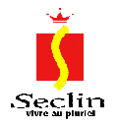

Proposes

The 5th EMPIRE TROPHY
of the « NERVIEN GUARD»
On June 17th and 18th 2006
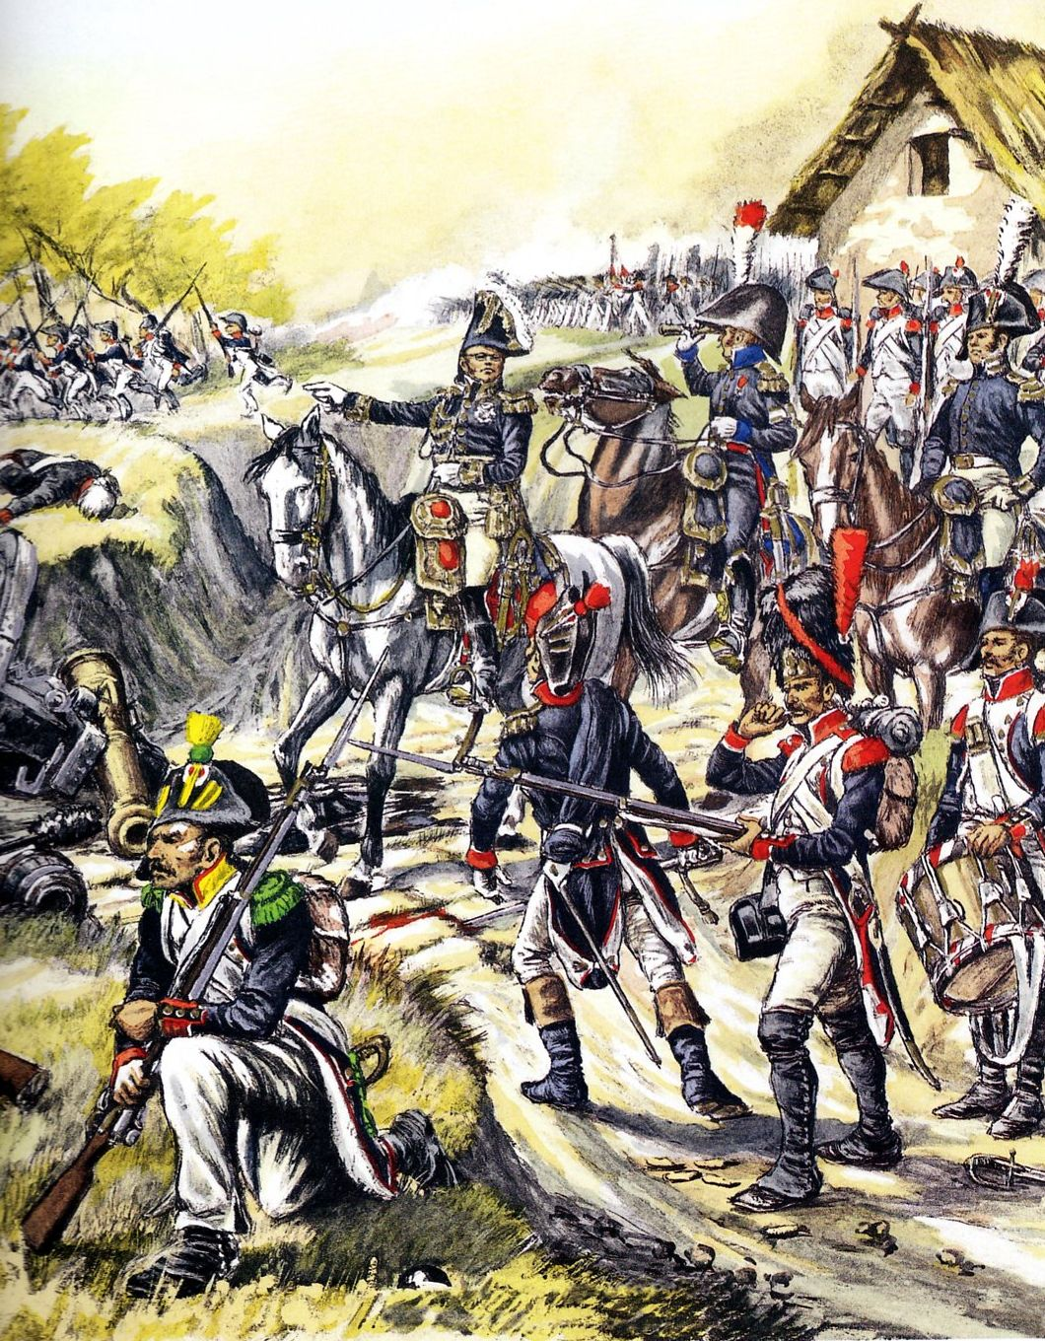

The tournament will be held in the historic Domaine Napoléon in Seclin
204, Rue de Burgault, 59113 SECLIN
Principle of the tournament :

1) Rule used : Tom Penn's Napoleonic Principle Of War, version 2.
2) Army lists: Those in NPOW version 2 with 60 points budget for all armies. Players are to follow the rule recommendations concerning the choice of troops.
3) The tournament is played either in teams (2 players) or singles (1 player) and will include 4 games of 3 ½ hours, each with a minimum of 8 turns.

4) Each team or single player must possess a French army and an opposing Army. As far as possible, each player will be fighting historical opponents (*). All lists in the rules are useable (there will be some armies for loan upon request).
(*) Note that some armies such as the Bavarians fought both for and against the French. It is therefore possible to fight with the same figures on two different lists.
5) Each team or single player will play 2 games on Saturday, and 2 games on Sunday. The 4 games will be played on different tables.

6) Terrain will be fixed and objectives designated in advance by the umpire. Terrains will be historical battlefields.
7) The result of each game will be calculated in accordance with the rules and a final classification established upon completion of the 4th game.

Organisation and information:

- M. Rohas Didier, 252 Rue de L’Authie, 62110 Hénin- Beaumont, Tél. : 03-21-49-19-56,
E-Mail : Didier.Rohas@wanadoo.fr
-M. Fremaut Laurent, 94, Rue Hector Berlioz, 59112 Annœullin, Tél. : 03.20.86.80.56,
E-Mail : lfremaut@yahoo.fr

Registration et participation :

- The registration fee for the tournament is 20 € (approx £14). Lunches are included as well as breakfasts Saturday and Sunday morning.
- Saturday night an evening meal on location is organized. Cost 15 € (approx £10) per person.

Access and accomodation :

- The tournament will be held in the Domaine Napoléon of Seclin, 204, Rue de Burgault, 59113 SECLIN, A1 motorway, exit 19 (direction Seclin), at the D925 roundabout take direction of Carvin, the Domaine is on the right a few hundred yards further.
- It is possible to sleep on site free of charge at the Domaine provided you bring your sleeping gear (sleeping bag, campbed, inflatable mattress, etc …). There is free access to the toilets and bathrooms.
- Choice of hôtels close by (few hundred yards), in the Z.A.C. de l'Épinette 59113 Seclin
- Hôtel Gril Campanile * * Tél. : 03.20.96.74.63
- Hôtel Première Classe Tél. : 03.20.96.72.08
- Fox hôtel Tél. : 03.20.96.87.00
- BB Hôtel Tél. : 08.92.78.80.54

Timetable :

Saturday June 17th
09h00 Doors open and welcome of participants
09h30 Start of tournament's first game
10h00 Doors open to the public
13h00 End of first game and lunch
13h30 Start of tournament's second game
17h00 End of second game
17h15 Visit of the Napoleon museum and Empire appartments
19h00 Drinks and meal organized by the Nervien Guard, Eve of Battle !

Sunday June 18th
08h30 Doors open and breakfast
09h00 Start of tournament's third game
10h00 Doors open to the public
12h30 End of third game and lunch
13h00 Start of tournament's final game
16h30 End of final game
17h00 Results announced and attribution of trophies
18h00 End of event and room closure
Tournament registration :

To be sent back before June 6th 2006 with proposed army lists and registration fee + cost of evening meal if chosen.

FIRST NAME AND FAMILY NAME …………………………………….…………………………………………………………..

ADDRESS : …………………………………………………………………………………..

…………………………………………………………………………………………………

Phone N° : ……………………………... ……….E-mail : ………..…………………..

Club : …………….………….. Armies played: ……………………………………………..
I wish to take part in the evening meal (15 €) : YES NO

TEAM MATE

FIRST NAME AND FAMILY NAME …………………………………….…………………………………………………………..

ADDRESS : …………………………………………………………………………………..

Phone N° : ……………………………... ……….E-mail : ………..…………………..

Club : …………….………….. Armies played: ……………………………………………..

